Newark
Scottish Country Dance Society

Walkthrough
Evening Social
with Iain Carmichael on accordion

Saturday 10th February 2024
6.15pm – 9.15pm
Bridge Community Centre
Newark NG24 2DQ
Tickets on the door £10.00 Spectators £5.00
Raffle
Please bring own mug and bring and share supper for the interval.

Granville Market | 8x32J
The Minister on the Loch | 3x32S
The Countess of Dunmore’s Reel | 8x32R
Mrs Stewart’s Jig | 8x32J
The Glengarry Homestead | 4x32S
City of Stirling Reel | 8x32R
Farewell to Balfour Road | 1x96J
Sands of Morar | 8x32S
Orpington Caledonians | 8x32R
----INTERVAL----
The Hazel Tree | 8x32J
Toast to the Mousies | 8x32R
MacDonald of Keppoch | 2x32S/2x32R
Good-Hearted Glasgow | 8x32J
The Falls of Rogie | 8x32R
Miss Eleanor | 3x32S
A Capital Jig | 8x32J
Tambourine | 8x32R

https://my.strathspey.org/dd/list/43289/

Dances will be walked through once, for the benefit of dancers who may
be attending a Social Dance for the first time.

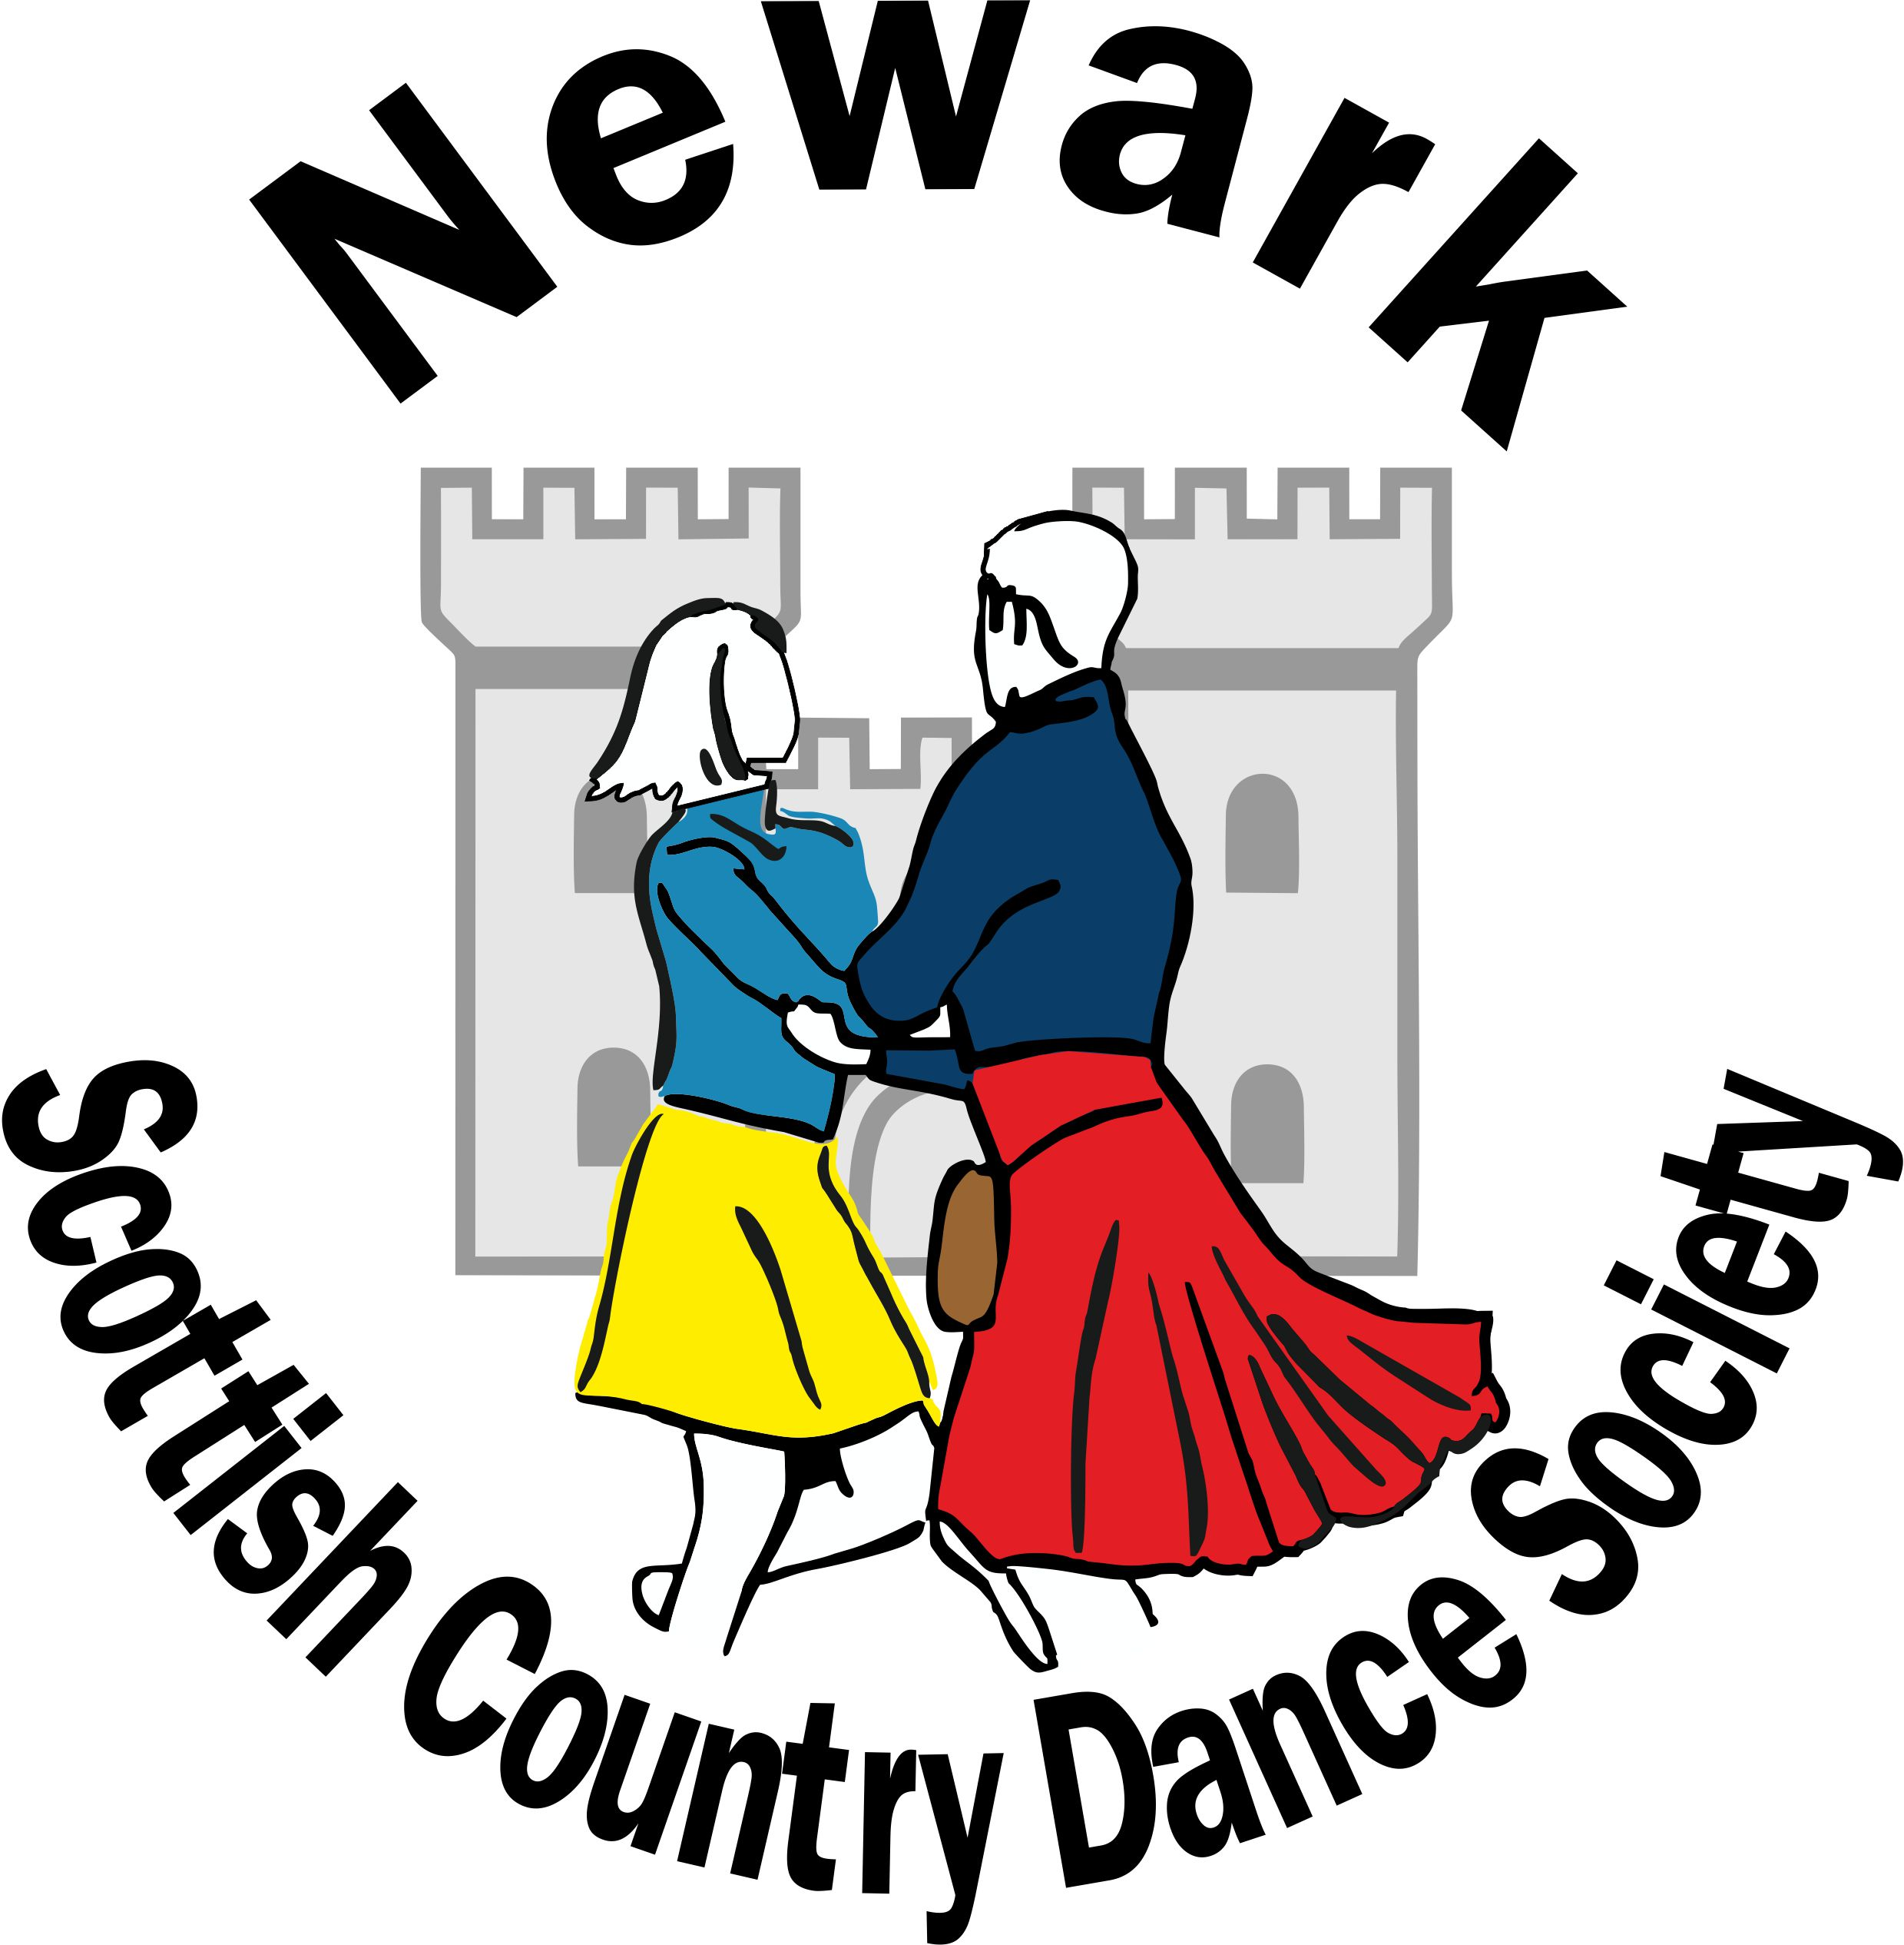
www.newarkscottishdancing.weebly.com

Day School

Saturday 10th February 2024

Bridge Community Centre
Lincoln Road
Newark NG24 2DQ

Teacher: Deb Lees

Musician: Iain Carmichael

For more information, contact
Chris Ronald (07449 661305)

Application Form
Surname …………………………………
First name (for name badge) …….…….
Address ………………………………….
…………………………………………….
…………………………………………….
Postcode …………. Phone …...………
Email ……………………………………..
Please tick requirements: Please print email.
 | Cost | Required
Morning Session | £8.00
Afternoon Session | £8.00
Lunch | £8.00
Lunch (Vegetarian) | £8.00
Total Payment
As all our food is prepared by volunteers, we cannot guarantee any ‘FREE FROMS’, though we will do our best to accommodate your wishes. If this is a major issue, we suggest that you bring your own lunch.
Payments by Bank Transfer (BACS or Faster Payment)
Lloyds Bank, Account Name: Newark SCDS
Sort Code: 30-98-97, Account Number: 64673568
Using your name and DY SCH as reference.
Or Cheque - payable to Newark SCDS, or Cash.
Send your completed form to:
Malc Jones
8 St Mary’s Rd, Bingham, Nottingham NG13 8DW
Tel: 07710622328
Email: malcjjones45@gmail.com
Applications will be dealt with as they are received as there will be a limit on numbers. A waiting list will be implemented if necessary. Your application will be acknowledged.
Deadline for receipt of applications: 31st December 2023
I understand that Newark Scottish Country Dance Society accepts no liability for loss or injury in connection with this event.

Signed ……………………………. Date …………….
Please use a separate form for each application- photocopies acceptable.

Newark Scottish Country
Dance Society

Day School
Saturday 10th February 2024

10.00 - 10.30 | Registration and coffee
10.30 - 12.30 | Fundamentals of Scottish country dancing
12.30 - 14.00 | Lunch
14.00 - 17.00 | Experienced/Advanced dancers  There will a 20-minute break for tea/coffee

Teacher: Deb Lees

Musician: Iain Carmichael

Location: Bridge Community Centre
Lincoln Road
Newark NG24 2DQ

The morning session is for dancers who aim to improve their steps, dance technique and gain confidence in dancing basic formations.

The afternoon session is for more experienced dancers who can confidently dance the main formations, including reels, poussettes and hello-goodbye setting. This knowledge will be assumed so the teacher can concentrate on developing further skills. Several of the figures taught will be drawn from the evening social dance programme.

It is expected that all participants will wear footwear appropriate for Scottish country dancing, such as ghillies.

